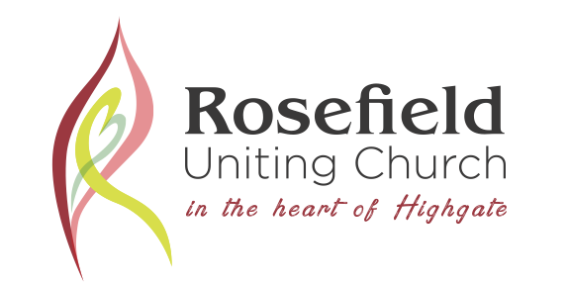
UKRAINE HUMANITARIAN ASSISTANCE (UHA)

CONCERN
Most of us are concerned and troubled by the human tragedy that is reported daily about the people of Ukraine as a result of the Russian invasion. Urgent help is needed in so many humanitarian ways and many organisations are seeking financial donations.
Ukraine Humanitarian Assistance has established a link where 100% of the donation goes immediately to assisting people on the ground.
CONTACT
Two of our community members, John & Helen Mills, volunteer with the organisation “Initiatives of Change”. This group has regular contacts with people in troubled parts of the world.
Initiatives of Change has direct contact with Community Solidarity Support Ukraine (CSSU) through its relationship with its founder Lena Kashkarova of Russian background, and ‘Dima’, Dmitriy Pritulenko who is Ukrainian. CSSU purchases supplies such as medicines, bandages, protective gear and other items from Europe and then distributes them to communities in Ukraine who have requested this survival support.
The website for CSSU is:
https://www.solidarity4ukraine.com.ua/ (note the .ua Address)
CONDITIONS
We are inviting persons to make donations through this Ukraine Humanitarian Assistance project.
Donations would be made either by Bank Transfer direct to Rosefield Uniting Church.
Bank Details are Bank ………………………….BSB 105-125
Account No 462696640 with a reference UHA
The Rosefield Uniting Church Treasurer will then regularly forward monies direct to Community Solidarity Support Ukraine.
Any finance queries to the Treasurer, Angela Zhang 8271 9528 or treasurer@rosefield.ucasa.org.au
As donations to UHA are not tax deductable, no receipt will be issued. However, 100% of the money will go directly to assisting people on the ground.

This UHA project comes with the approval of the Rosefield Uniting Church Council.

For any further information, please contact John Mills 0432 439 581 or Ian Stewart 0412 094 477 or the office on 08 8271 9528.

